Create the K8s EKS further, you have to do the deployment of the Nginx application and access the application outside the cluster.

First, we need to configure the aws in our visual code.

For that, we need to create the user in the iam user

After that, we get the access key and secret key under security credentials.

After creating the user, we need to create the roles

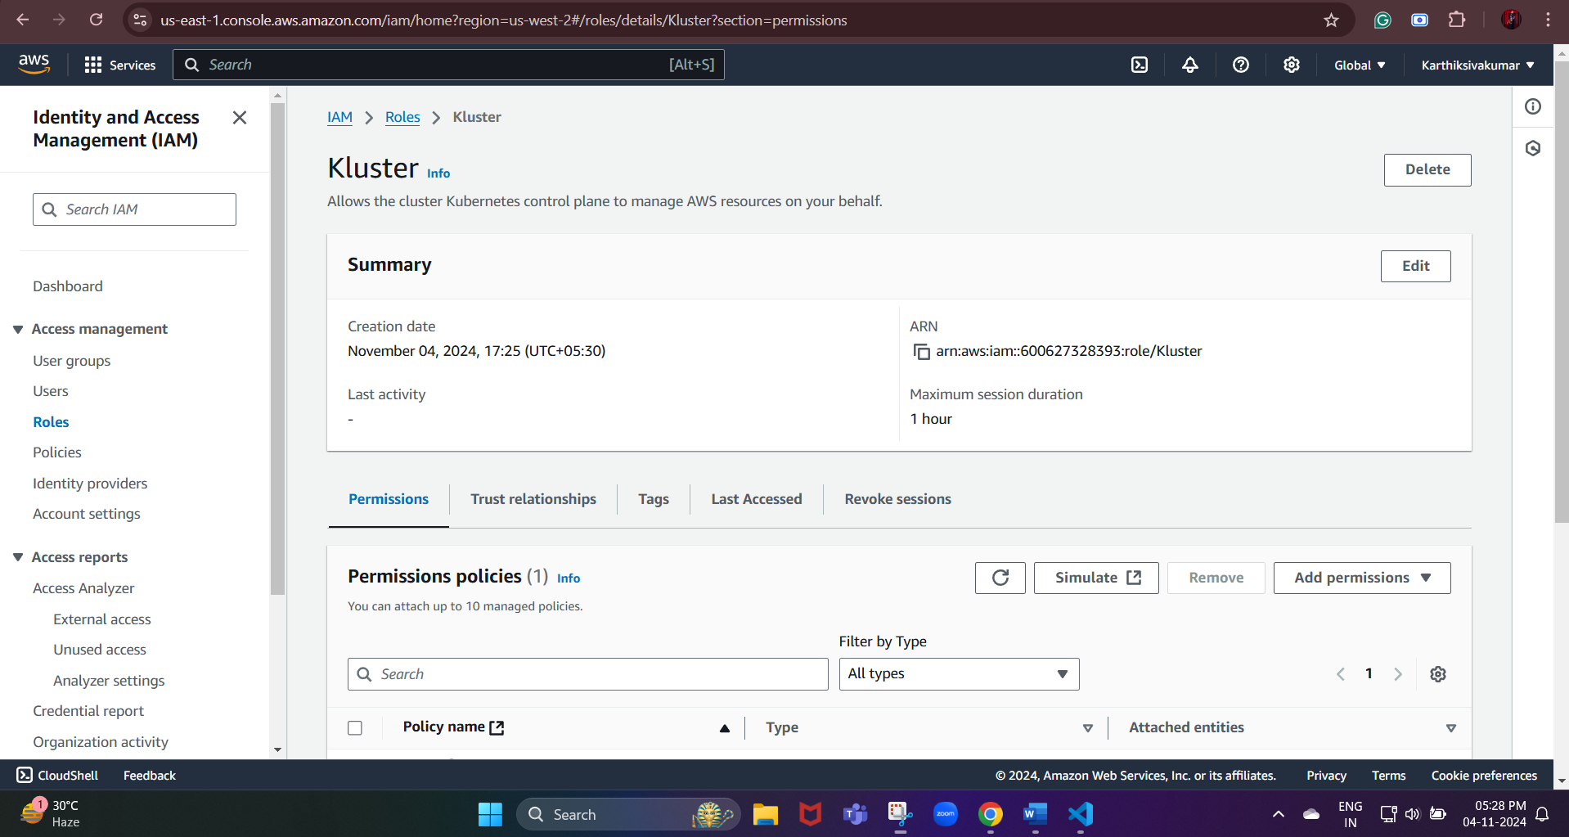

aws eks create-cluster `

--name my-eks-cluster `

--region us-west-2 `

--role-arn arn:aws:iam::600627328393:role/Kluster `

--resources-vpc-config subnetIds=subnet-091099e737e69c6ce,subnet-0406304df96a68934,securityGroupIds=sg-0989960ff48439a75

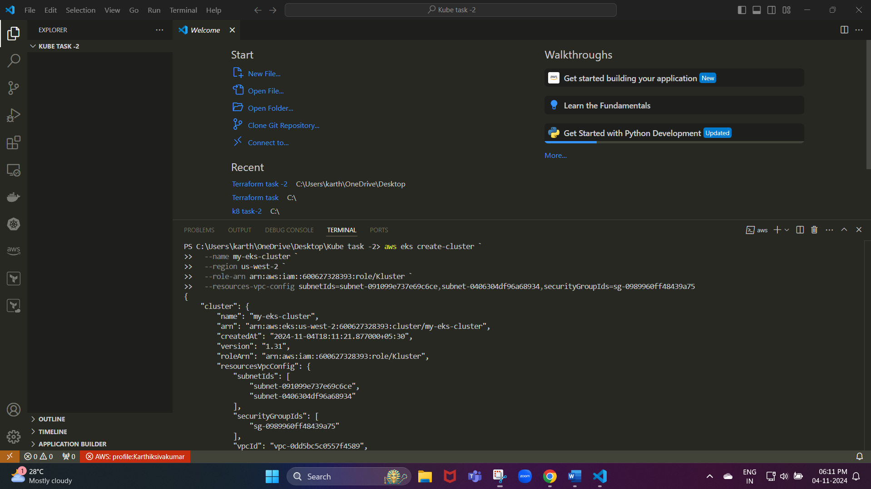

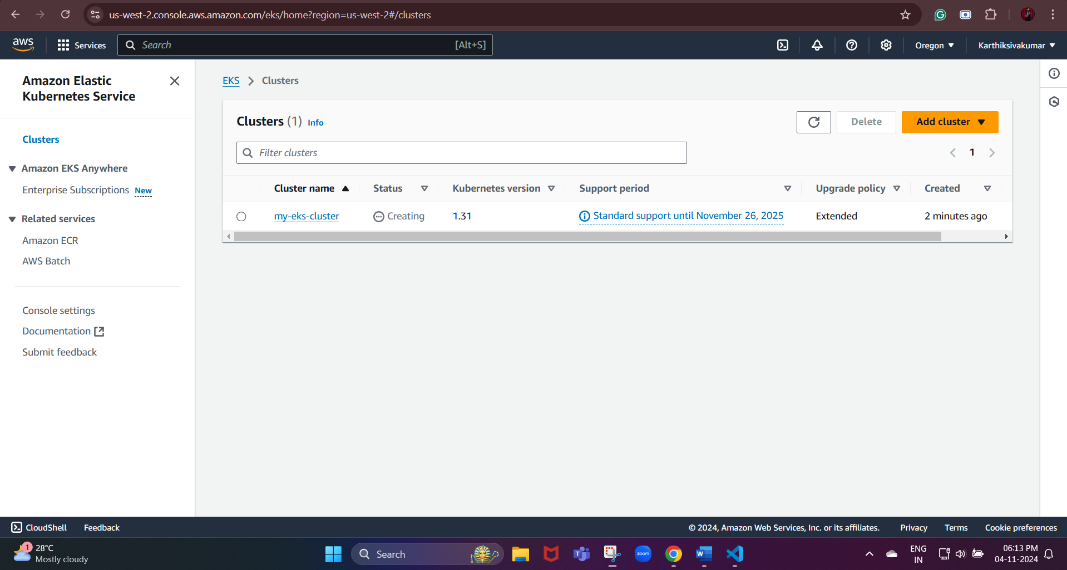

Now, the cluster has been created.

Next, we need to create the worker node

To check the status of the cluster:

command:

aws eks describe-cluster --name my-eks-cluster --region us-west-2

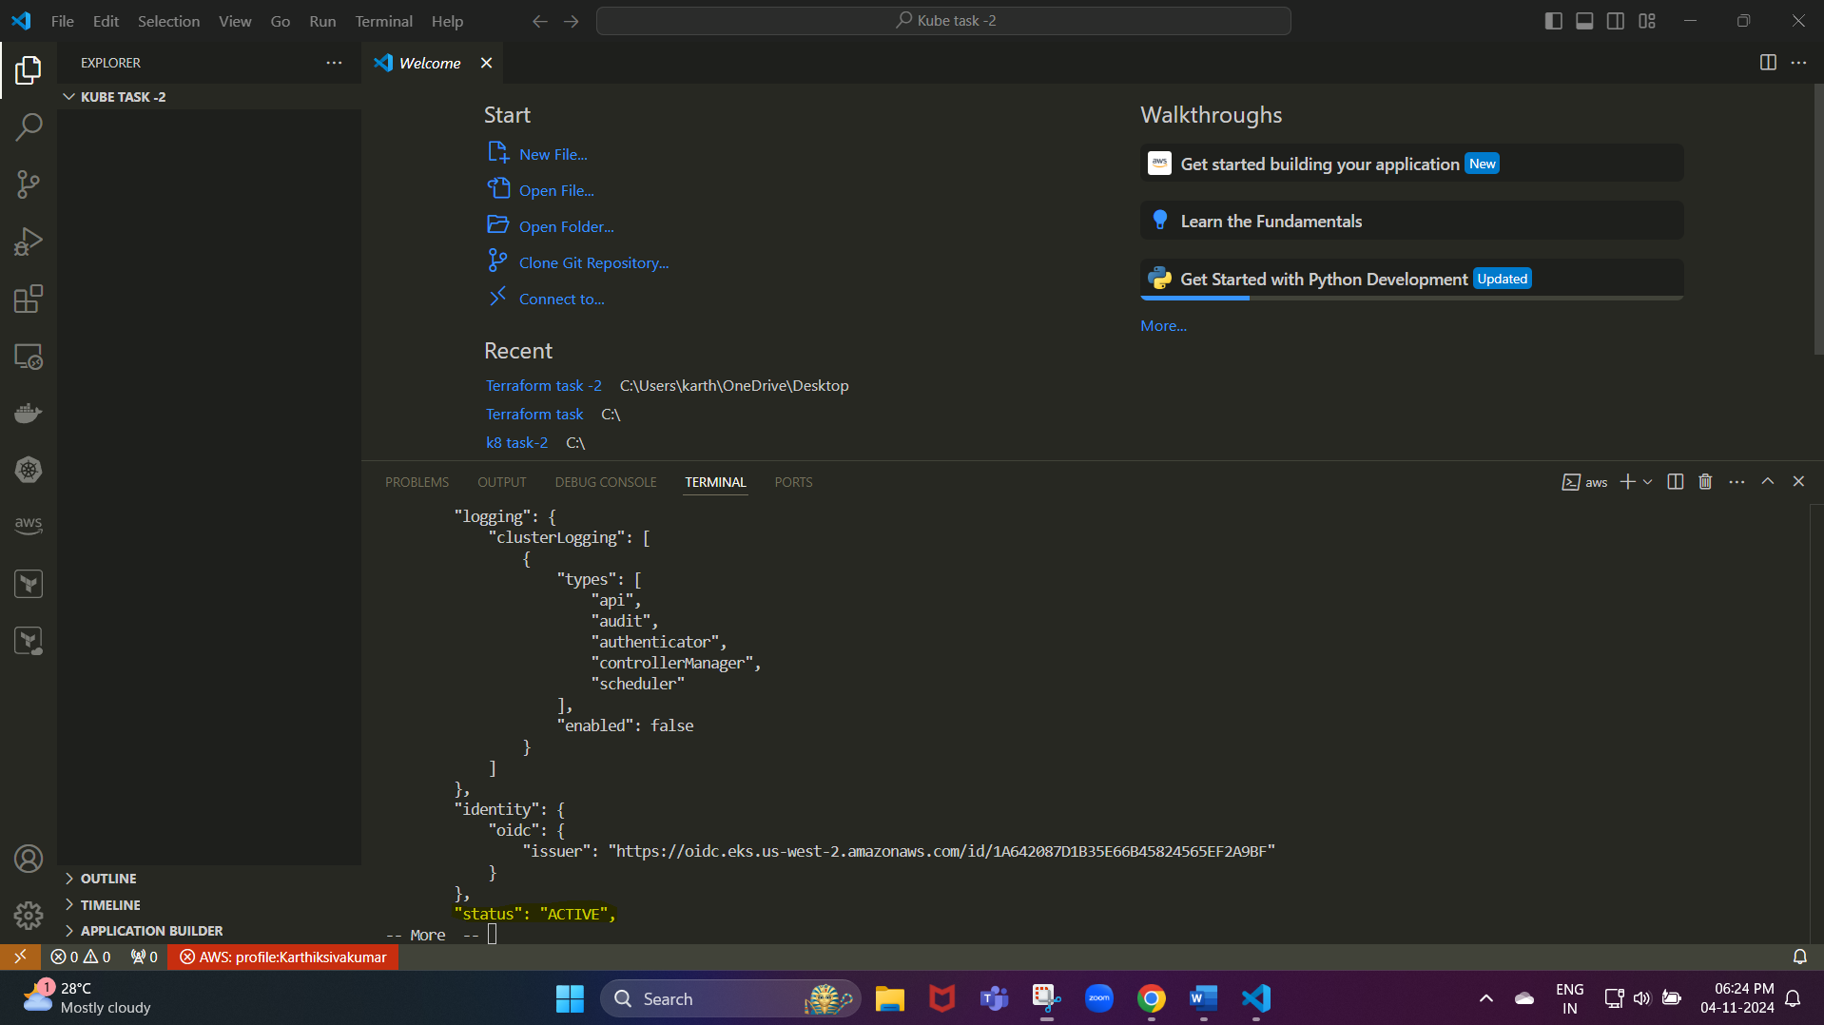We need to wait until it gets active.

